Problem 1: Cost flow assumptions under perpetual inventory system
For the below scenarios, all units are sold at a price of $18.50 each. Using the perpetual system, what are COGS, gross profit, and ending inventory for:
(a) FIFO
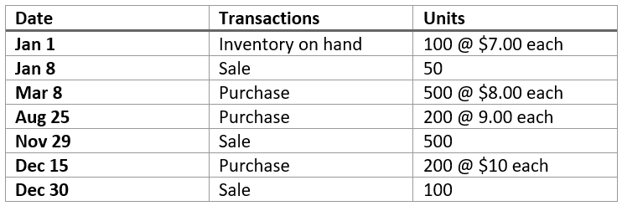

(b1) LIFO


(b2) LIFO, continued: At period end, they count actual inventory of 325 units. What is the journal entry?

Inventory Costs: Bonus Problem 1
Problem: Inventory cost & timing
Boulder Bikes orders 1,500 units of brake pads at $10 each from BrakeCo. Terms are FOB Shipping Point.
- Inventory Shipped: 12/28/2024
- Inventory Received: 01/02/2025
- Discount: A 2% discount is offered for prepayment, and Boulder Bikes takes the discount (deducted from the BrakeCo. invoice).
- Freight-in: Boulder Bikes pays $175 to ShipCo.
Required
- What amount should Boulder Bikes capitalize as inventory?
- On what date should Boulder Bikes’ financial statements reflect the inventory?

Sales Discount: Bonus Problem – Partial Payment
On October 1, Mariner Co. provided services worth $800 on account to a customer with terms 2/15, n/30.
The customer paid $294 on October 12 and the remaining balance on October 25.

- Under the Gross/net Method:
  - Record the journal entry on October 12 when the customer makes the first payment.

  - Record the journal entry on October 25 when the customer pays the remaining balance.

- Under the Net Method:
  - Record the journal entry on October 12 for the first payment.

  - Record the journal entry on October 25 for the remaining payment.

